AI-Generated Visual Content Detection and Media Trust
Zheng Xing, Zhang Gaoxiang, Xiong Yubo, and Wang Dexing
Class 3, Group 6

Introduction
Generative AI is no longer limited to producing obviously artificial images. Newer image models can generate photorealistic scenes, readable text, and interface-like layouts. OpenAI’s GPT Image 2, for example, is documented as a current image model with the snapshot gpt-image-2-2026-04-21 (OpenAI, 2026a). This technical shift matters socially because online images are often treated as evidence. A screenshot of a livestream, a social media post, or a chat interface does not merely look like a picture; it appears to carry platform context, timestamps, comments, accounts, and other cues of authenticity.
This paper focuses on that changing status of visual evidence. Previous research has shown that people often struggle to distinguish AI-generated media from human-created or real media (Frank et al., 2024; Roca et al., 2025). Recent work also suggests that realistic AI-synthesized images can increase belief in misinformation when they seem to provide strong evidence for a claim (Guo et al., 2025), while AI-generated images are already being used by spammers and scammers on social platforms for audience growth (DiResta & Goldstein, 2024). At the same time, screenshots occupy a special position in online communication because they are frequently circulated as visual proof rather than as ordinary photographs (Inwood & Zappavigna, 2024).
This paper asks the following research question: How accurately did university-level respondents distinguish AI-generated images from real images across common online visual categories, and how did their trust ratings differ by image source and category? To answer this question, the study uses a small-scale Wenjuanxing survey as its main local data source. Existing studies on synthetic media detection, misinformation, and visual evidence are used to frame and interpret the survey findings.

Methods

Research Design
This study used a small-scale quantitative survey design. The Wenjuanxing survey provided the main local data for testing how university-level respondents judged AI-generated and real visual materials. Previous studies were used as background evidence because they explain why human detection of AI-generated images is difficult and why screenshot-like materials can influence credibility.

Participants and Sample
Participants were recruited through convenience sampling and completed the survey online through Wenjuanxing. A total of 79 responses were collected. Ten responses failed the Q42 attention-check item, and three attention-check passers reported “high school or below” as their current education level. These responses were excluded from the main analysis so that the analytic sample matched the study’s university-level focus. The final analytic sample therefore included 66 valid university-level respondents.
Within this analytic sample, 26 respondents were first-year students, 14 were second-year students, 10 were third-year students, and 16 were fourth-year-or-above students or recent graduates. Most respondents used social media for at least one hour per day, and most had used AI tools either daily or weekly.

Materials
The survey used image-only materials. It contained eighteen visual items: nine AI-generated images and nine real images. The materials covered both ordinary photorealistic images and screenshot-like visual evidence. The five categories were text-bearing visual artifacts, portrait images, livestream commerce screenshots, food photographs, and virtual livestream or VTuber interface images.
The 18 items were selected purposively rather than randomly. Because the study focused on online visual credibility, the materials were chosen to cover five visual types that people commonly encounter on digital platforms. The set was also balanced by source, with nine AI-generated images and nine real images. Therefore, the materials should not be treated as a statistically representative sample of all online images; they were designed to compare responses across selected image categories. The participant-facing questionnaire did not reveal whether a file was AI-generated or real.
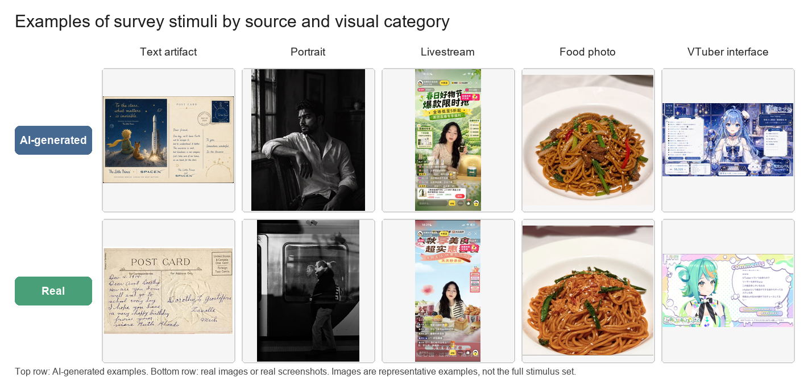
Figure 1. Examples of survey stimuli by source and visual category.

Measures
The survey included source-judgement items, trust-rating items, attitude items, one attention check, and one optional open-ended question. For each image, participants first judged its source on a five-point scale from “definitely real” to “definitely AI-generated.” They then rated how trustworthy the same image would seem if it appeared on social media or another online platform.
Detection accuracy was calculated as the proportion of correctly classified source-judgement items. For binary accuracy scoring, “definitely real” and “probably real” were counted as correct for real images, while “probably AI-generated” and “definitely AI-generated” were counted as correct for AI-generated images. “Unsure” was treated as incorrect for the main accuracy score. Trust was measured through one five-point rating for each image.

Procedures
The survey had three sections. First, to describe the sample and control for relevant background differences, participants reported their year of study, daily social media use, AI tool use, and self-assessed ability to identify AI-generated or edited online images. Second, to measure source judgement before credibility judgement, participants completed the image task in two steps for each visual item. They first judged whether the image was real or AI-generated, and after that they rated how trustworthy the same image would seem if it appeared on social media or another online platform. Third, after finishing all image tasks, participants answered four media-trust attitude questions, one Q42 attention-check item, and one optional open-ended question about the cues they used.
No feedback was given during the task so that later answers would not be influenced by earlier corrections. Because the study compared responses across visual categories, the Wenjuanxing version grouped materials of the same type together. During analysis, responses that failed Q42 were flagged and excluded before detection accuracy and trust scores were calculated.

Results
The Wenjuanxing survey collected 79 responses. Of these, 69 responses passed the Q42 attention-check item, giving an attention-check pass rate of 87.3%. After excluding three attention-check passers who were outside the university-level target group, the final analytic sample included 66 valid responses.
Table 1. Sample screening and final analytic sample
Screening step | Responses
Submitted responses | 79
Passed Q42 attention check | 69
Excluded for non-university-level education | 3
Final analytic sample | 66
Across all 18 image source-judgement items, the mean detection accuracy was 47.4%. Accuracy was higher for AI-generated images (52.9%) than for real images or screenshots (41.9%). This means that respondents were not simply accepting all images as real; many real images were also treated with suspicion and misclassified as AI-generated.
Table 2. Source-judgement accuracy by visual category
Image category | Accuracy
Livestream commerce screenshots | 58.3%
Text-bearing visual artifacts | 56.8%
Virtual livestream interfaces | 54.5%
Portrait images | 39.8%
Food photographs | 31.1%
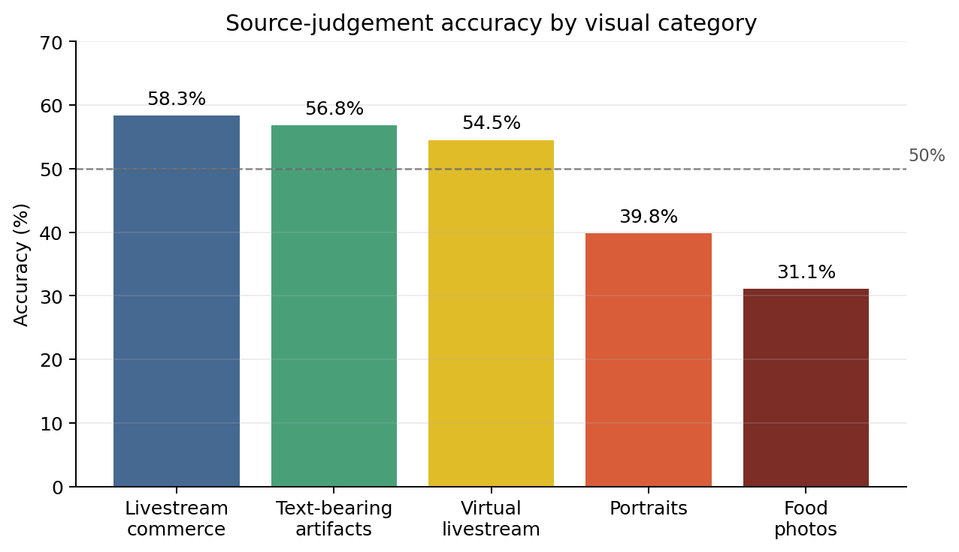
Figure 2. Source-judgement accuracy by visual category.
Trust ratings were measured on a five-point scale from 1 (“not trustworthy at all”) to 5 (“very trustworthy”). Real images received a slightly higher mean trust rating (M = 2.99) than AI-generated images (M = 2.70), but the difference was modest. By category, portrait images received the highest average trust rating (M = 3.14), followed by text-bearing visual artifacts (M = 2.98), virtual livestream interfaces (M = 2.73), livestream commerce screenshots (M = 2.70), and food photographs (M = 2.62).
The attitude items showed a cautious pattern of media trust. Respondents generally did not agree that online images and screenshots usually reflect reality (M = 2.39). At the same time, many respondents agreed that platform elements such as interfaces, comments, or livestream features can make screenshots more believable. Most respondents also reported verification habits: 42 out of 66 agreed or strongly agreed that they would look for sources or context when seeing realistic online images or screenshots.

Discussion

Summary of Findings
This study examined how university-level respondents judged AI-generated and real online visual materials. The main finding is that source judgement was unstable. Across 18 image items, the overall source-judgement accuracy was 47.4%, which means that respondents classified fewer than half of the images correctly. Accuracy was higher for AI-generated images (52.9%) than for real images and screenshots (41.9%). This pattern suggests that respondents were not only fooled by AI-generated images; they also became suspicious of real images.
The category-level results show the same problem from another angle. Livestream commerce screenshots had the highest accuracy (58.3%), followed by text-bearing visual artifacts (56.8%) and virtual livestream interfaces (54.5%). Portrait images had lower accuracy (39.8%), and food photographs had the lowest accuracy (31.1%). Trust ratings were also moderate rather than high. Real images received a slightly higher mean trust rating (M = 2.99) than AI-generated images (M = 2.70), but the difference was small. These findings suggest that visual authenticity is becoming difficult to judge, especially when real images look polished or artificial.

Comparison with Previous Studies
The local survey results are consistent with previous research on AI-generated media detection. Frank et al. (2024) and Roca et al. (2025) both show that people often have difficulty distinguishing AI-generated media from real or human-created media. The current survey found a similar pattern: the overall accuracy was close to chance level, even though many respondents reported frequent exposure to AI tools. This supports the idea that general familiarity with AI does not automatically lead to reliable detection ability.
The findings also connect with research on trust and misinformation. Guo et al. (2025) argue that realistic AI-synthesized images can make false information more persuasive when the images appear to provide evidence for a claim. In this study, AI-generated images did not receive very high trust ratings overall, but they were sometimes trusted at levels close to real images. This matters because even moderate trust in synthetic images may be enough to make online claims seem more credible.
Finally, the findings relate to Inwood and Zappavigna’s (2024) argument that screenshots often function as visual evidence in online communication. The attitude results in this survey support that point: many respondents agreed that platform elements such as interfaces, comments, and livestream features can make screenshots more believable. Therefore, the risk of AI-generated screenshots is not only that they may be hard to detect. Their platform-like details can also make them look socially and contextually credible.

Possible Reasons
One possible reason for the low overall accuracy is that respondents may have used surface visual cues too heavily. Some real food photographs and portraits looked polished, staged, or digitally processed, so respondents may have assumed that they were AI-generated. This helps explain why real images had lower accuracy than AI-generated images. The spread of synthetic images may lead users to over-doubt real images, especially when those images look too clean or visually perfect.
A second reason is that the materials were selected purposively. The 18 images were chosen to represent common online visual categories, including text-bearing images, portraits, livestream commerce screenshots, food photographs, and virtual livestream interfaces. Because the set was not a random sample of all online images, the results should not be generalized too broadly. However, this purposive design was useful for comparing how respondents reacted to different types of online visual evidence.
A third reason is that screenshot-like materials provide contextual cues. Elements such as platform layout, comments, prices, usernames, or livestream interfaces can make an image feel less like a standalone picture and more like a record of an online event. These cues may increase perceived credibility even when viewers are unsure about the image source. For this reason, AI-generated visual misinformation should be understood not only as a problem of fake photographs, but also as a problem of fake visual context.
Overall, the study suggests that ordinary visual judgement is not enough for evaluating AI-generated online images. Respondents showed limited accuracy, moderate trust, and some uncertainty about both real and AI-generated materials. As image-generation tools become better at producing realistic images, readable text, and interface-like screenshots, users may need clearer platform labels, stronger verification habits, and better media literacy training.

References
DiResta, R., & Goldstein, J. A. (2024). How spammers and scammers leverage AI-generated images on Facebook for audience growth. Harvard Kennedy School Misinformation Review. https://doi.org/10.37016/mr-2020-151
Frank, J., Herbert, F., Ricker, J., Schönherr, L., Eisenhofer, T., Fischer, A., Dürmuth, M., & Holz, T. (2024). A representative study on human detection of artificially generated media across countries. Proceedings of the 45th IEEE Symposium on Security and Privacy. https://arxiv.org/abs/2312.05976
Guo, S., Zhong, Y., & Hu, X. (2025). People are more susceptible to misinformation with realistic AI-synthesized images that provide strong evidence to headlines. Harvard Kennedy School Misinformation Review. https://doi.org/10.37016/mr-2020-189
Inwood, O., & Zappavigna, M. (2024). The legitimation of screenshots as visual evidence in social media: YouTube videos spreading misinformation and disinformation. Visual Communication. https://doi.org/10.1177/14703572241255664
Metzger, M. J., & Flanagin, A. J. (2013). Credibility and trust of information in online environments: The use of cognitive heuristics. Journal of Pragmatics, 59, 210-220. https://doi.org/10.1016/j.pragma.2013.07.012
Nightingale, S. J., & Farid, H. (2022). AI-synthesized faces are indistinguishable from real faces and more trustworthy. Proceedings of the National Academy of Sciences, 119(8), e2120481119. https://doi.org/10.1073/pnas.2120481119
OpenAI. (2026a). GPT Image 2 model. OpenAI API. https://developers.openai.com/api/docs/models/gpt-image-2
Pennycook, G., & Rand, D. G. (2021). The psychology of fake news. Trends in Cognitive Sciences, 25(5), 388-402. https://doi.org/10.1016/j.tics.2021.02.007
Roca, T., Cintron Roman, A., Torres Vega, J., Duarte, M., Wang, P., White, K., Misra, A., & Lavista Ferres, J. (2025). How good are humans at detecting AI-generated images? Learnings from an experiment. arXiv preprint. https://arxiv.org/abs/2507.18640
Vaccari, C., & Chadwick, A. (2020). Deepfakes and disinformation: Exploring the impact of synthetic political video on deception, uncertainty, and trust in news. Social Media + Society, 6(1). https://doi.org/10.1177/2056305120903408

